WMD WEBSITE REPORT

WEBSITE SPECIFICATION
OBJECTIVES AND GOALS
The objective of the Campus Survival Hub website is to provide a platform that assists students in hostels to adapt to campus life. The website offers guidance on accommodation, budgeting and accessing academic resources.
The goals of the website are:
- To help first year students transition into hostel life
- To provide practical advice on managing finances on daily living
- To offer access to useful academic and online resources
- To improve the overall student experience in campus accommodation
TARGET AUDIENCE
The target audience for this website includes:
- First year students entering campus hostels
- Continuing students living in students’ accommodation
- Students aged between 18-23 years
These users are familiar with digital devices such as smartphones and laptops and require easy access to information in a clear and simple way.
TYPE OF WEBSITE
Campus Survival Hub is an informational and service-based website. It functions as a student support platform that provides guidance and resources related to hostel living and campus survival.

INFORMATION DESIGN AND TAXONOMY
This website content is structured into clearly defined sections to insure easy navigation and usability.
SITE STRUCTURE
The website consists of the following pages:
- Home page (index.html)
- First-Year Guide
- Dorm life
- Student Budget
- Student Resources
- Feedback Page
NAVIGATION STRUCTURE

A consistent navigation bar is used across all pages. This allows users to easily move between sections of the website
The navigation is simple and ensures that users can access any page within one or two clicks
SITE MAP

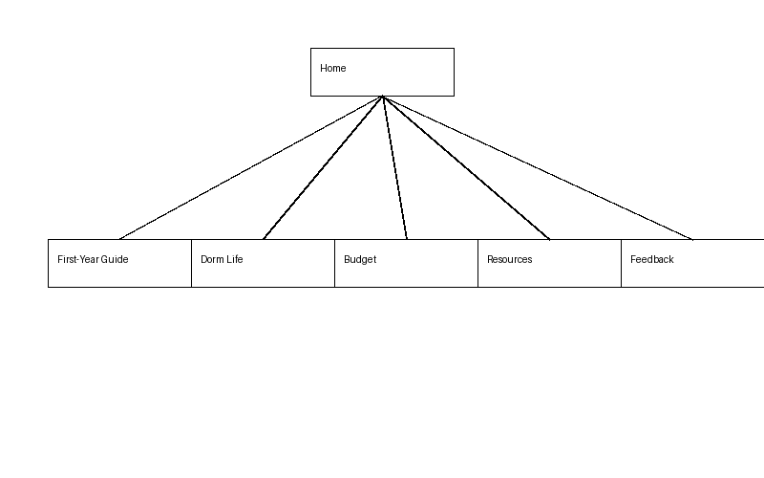
This structure ensures that content is logically grouped and easy to locate.

PAGE TEMPLATE DESIGN
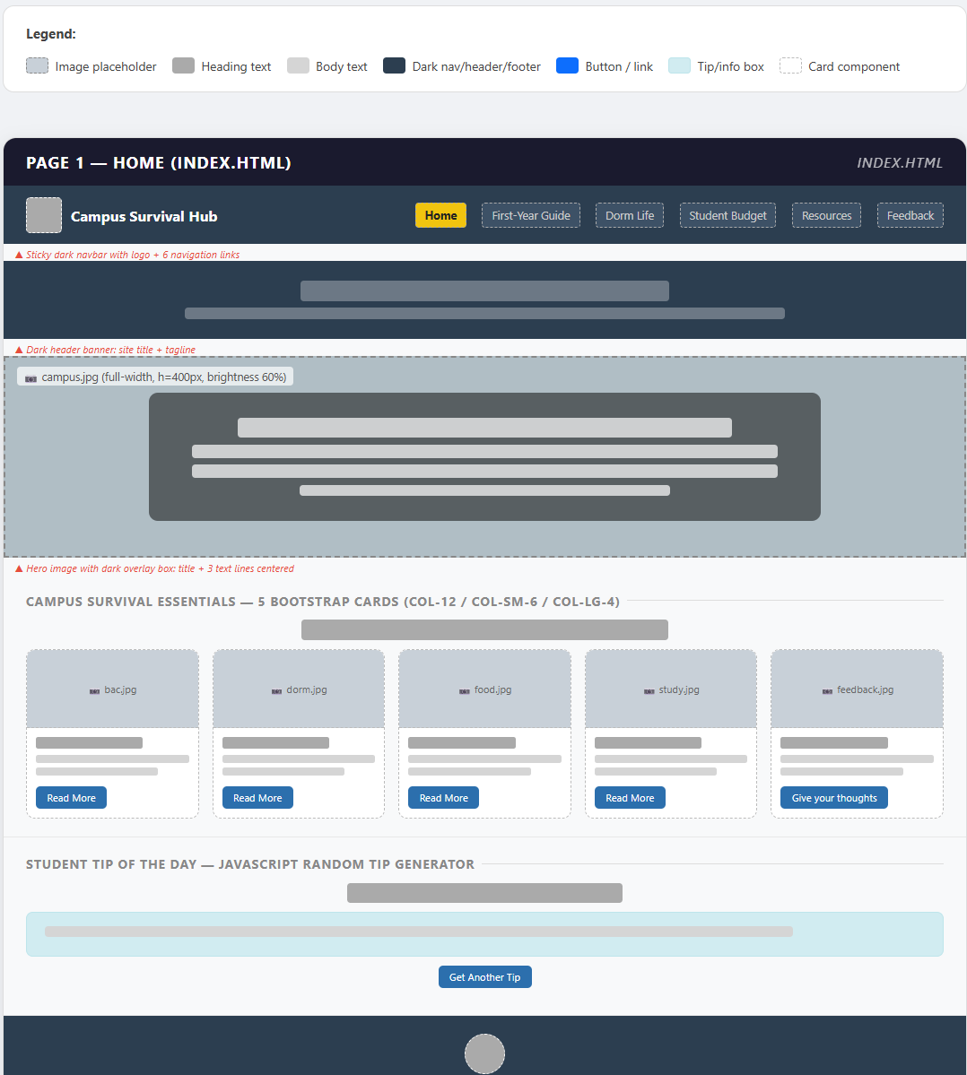
The following wireframes show the detailed page template design for the Campus Survival Hub website. Each wireframe is based on the actual developed website and illustrates the layout, content placement, and navigation structure of each page. The wireframes demonstrate consistent use of active white space, clearly defined content sections, and a uniform design across all six pages.
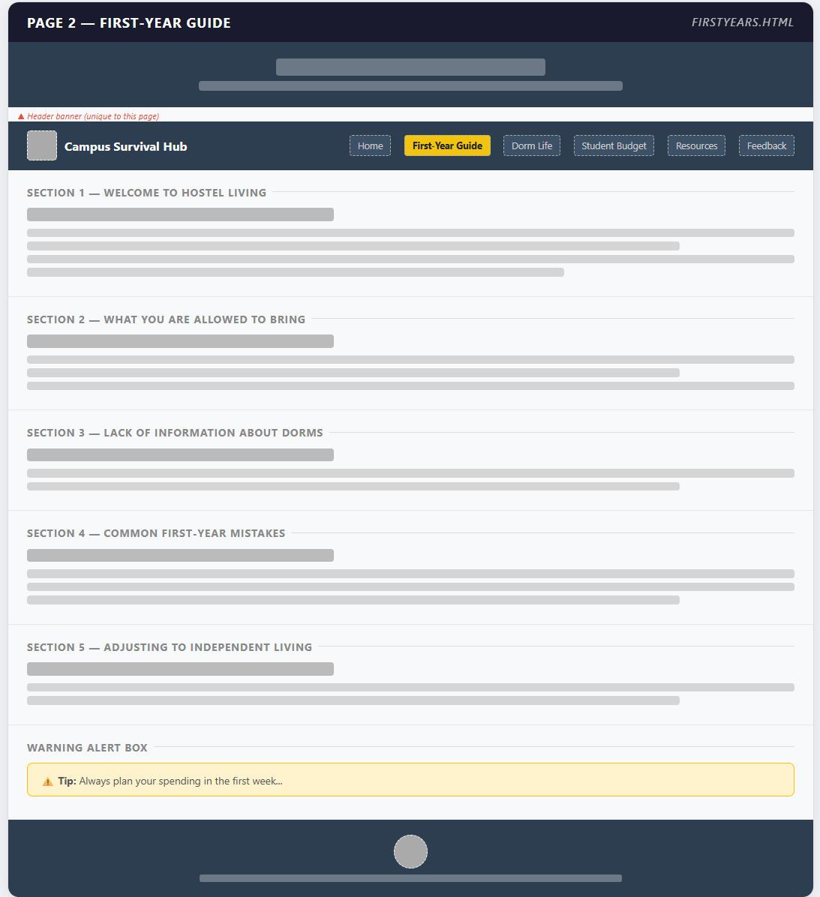
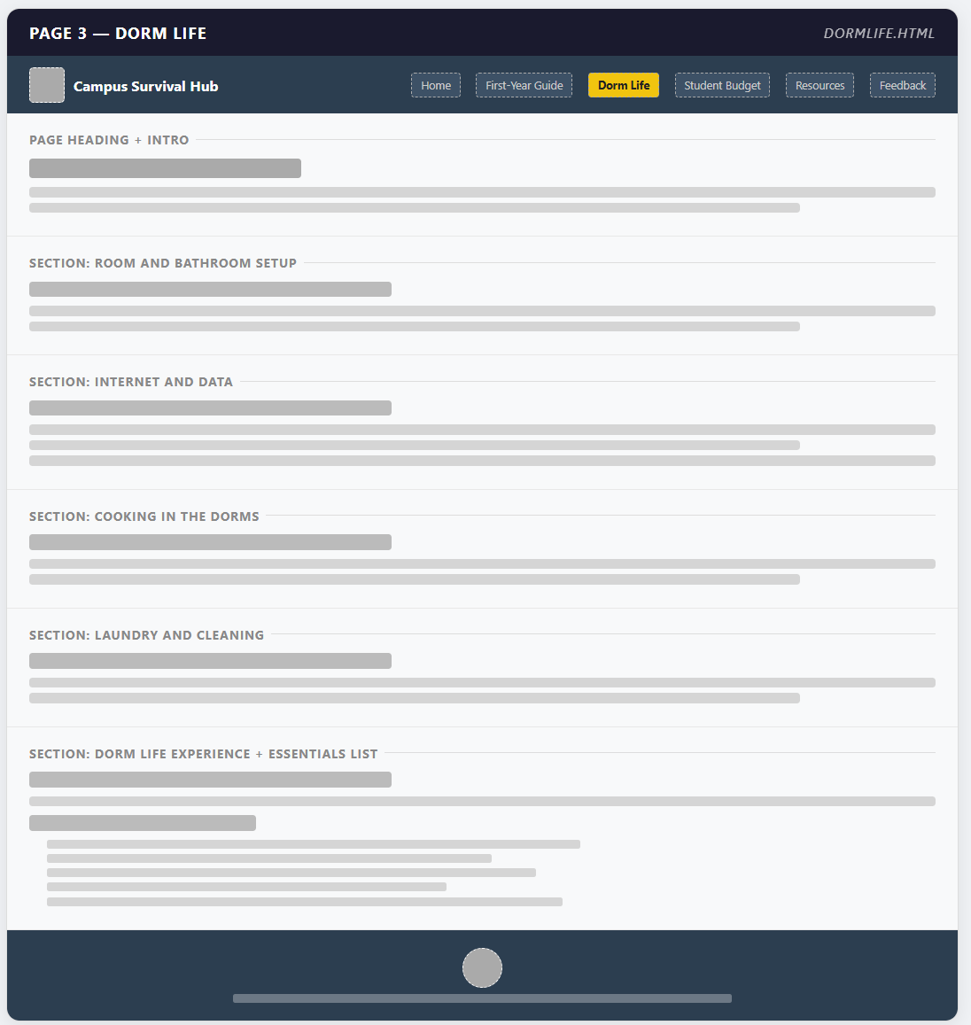
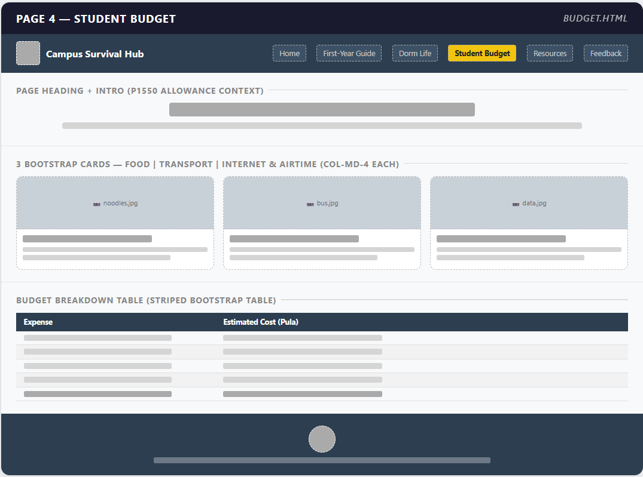
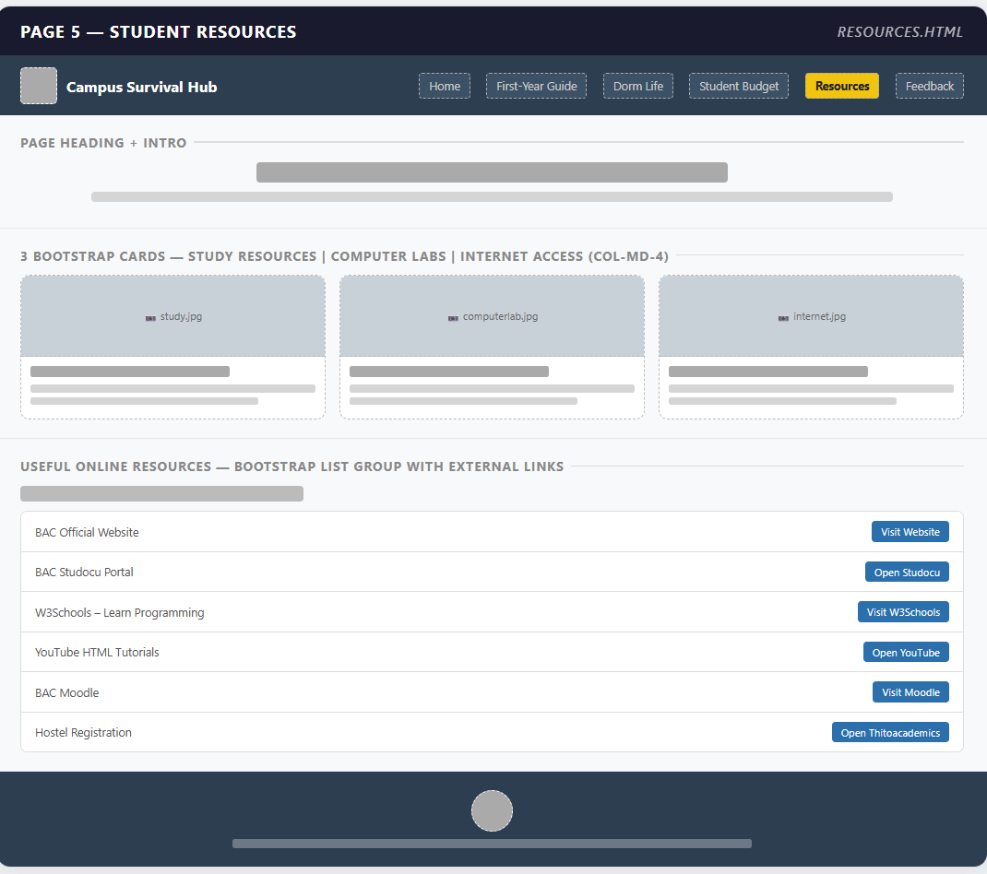
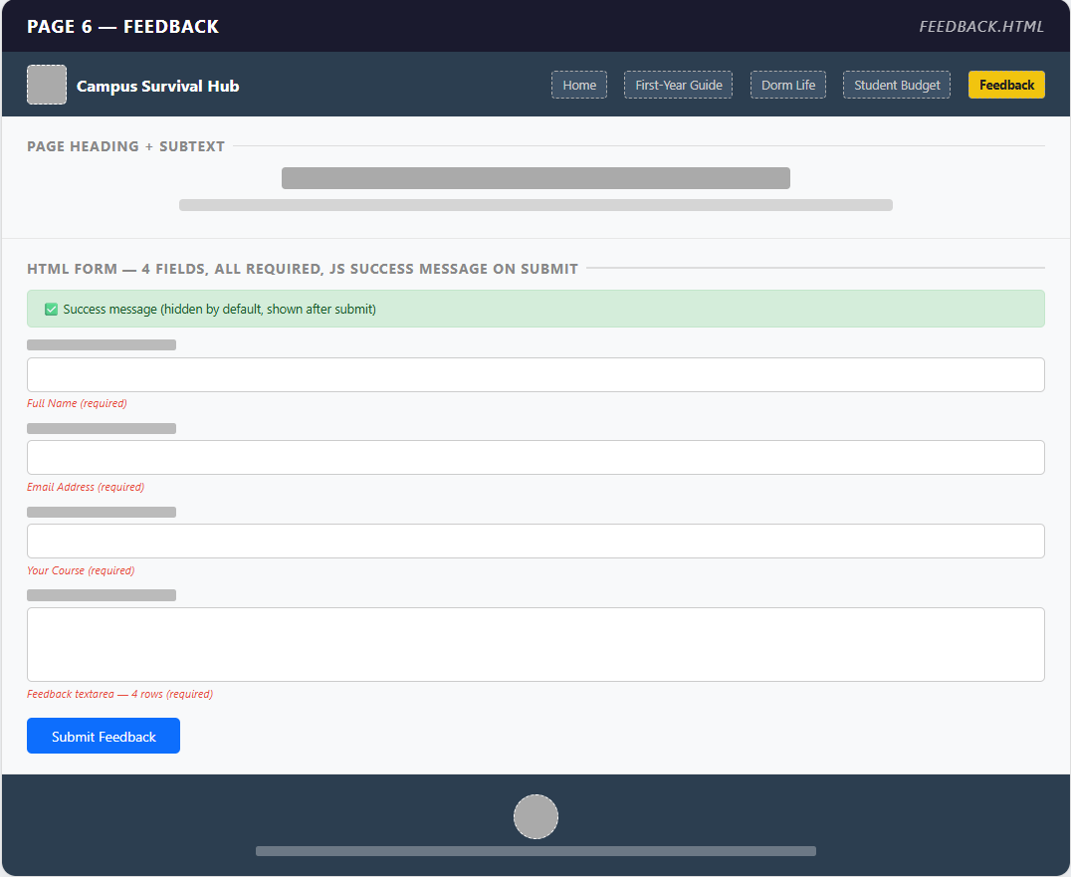

TECHNICAL BRIEF
This website was developed using the following technologies:
- HTML5 for structuring the content
- CSS3 for styling and layout design
- Bootstrap 5 for responsive design and layout components
- JavaScript for interactivity, including:
- Student tip generator
- Scroll to top button
- Visual Studio Code as the development environment
- GitHub for version control and hosting
Bootstrap was used to ensure that the website is responsive and works on different screen sizes such as mobile phones, tablets and desktop computers.

Quality Assurance and Testing
The website was tested to ensure that it functions correctly across different devices and browsers.
Testing was conducted on the following:
- Mobile devices (smartphones)
- Desktop computers (PC)
The website was tested for:
- Proper layout and responsiveness using Bootstrap
- Navigation between pages
- Functionality of interactive features such as:
  - Student tip generator
  - Back-to-top button
  - Feedback form validation
All pages were confirmed to load correctly, and the layout adjusts properly depending on screen size.
Screenshots of the website on both mobile and desktop devices are included below as evidence of testing.
- Desktop
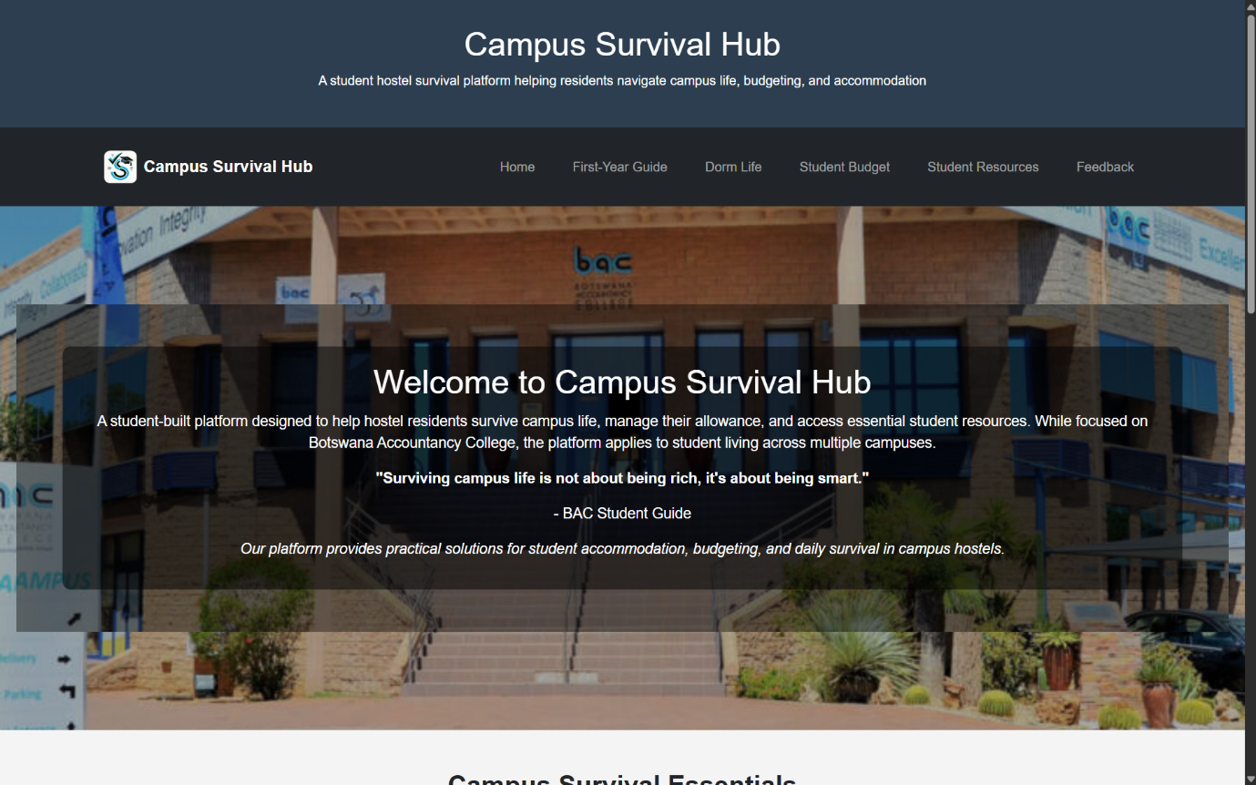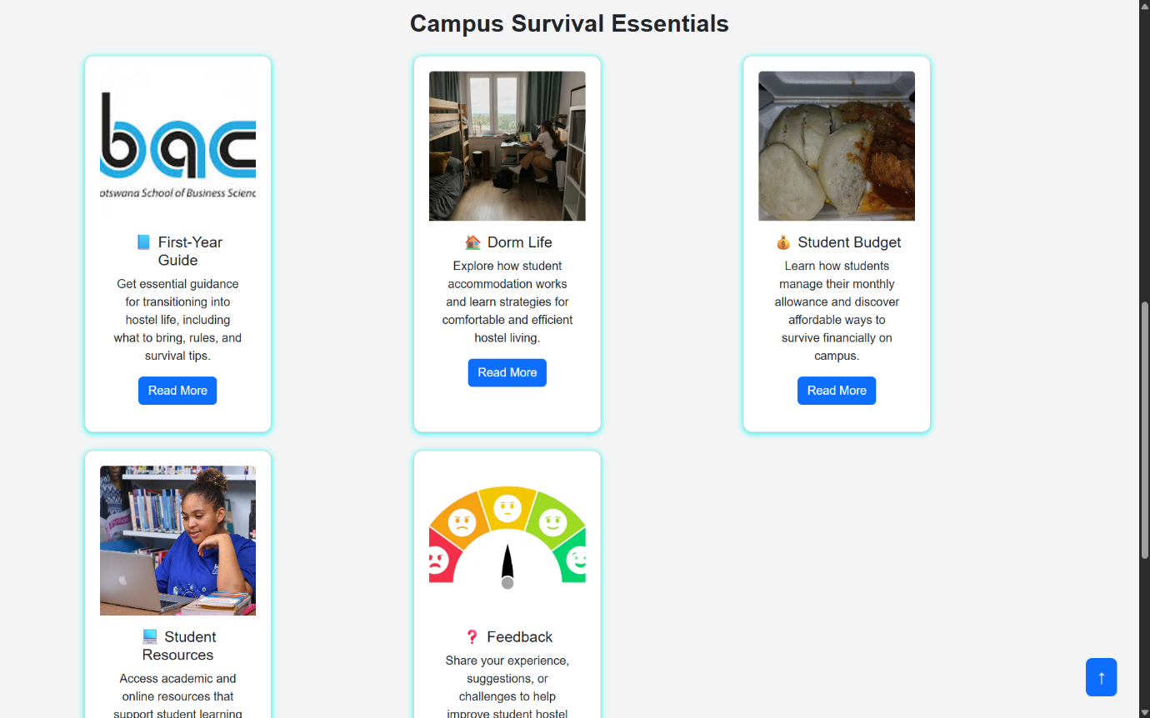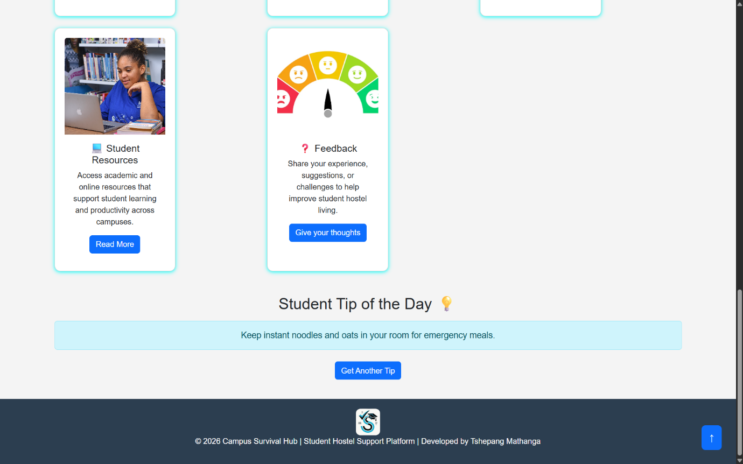

- Mobile phone
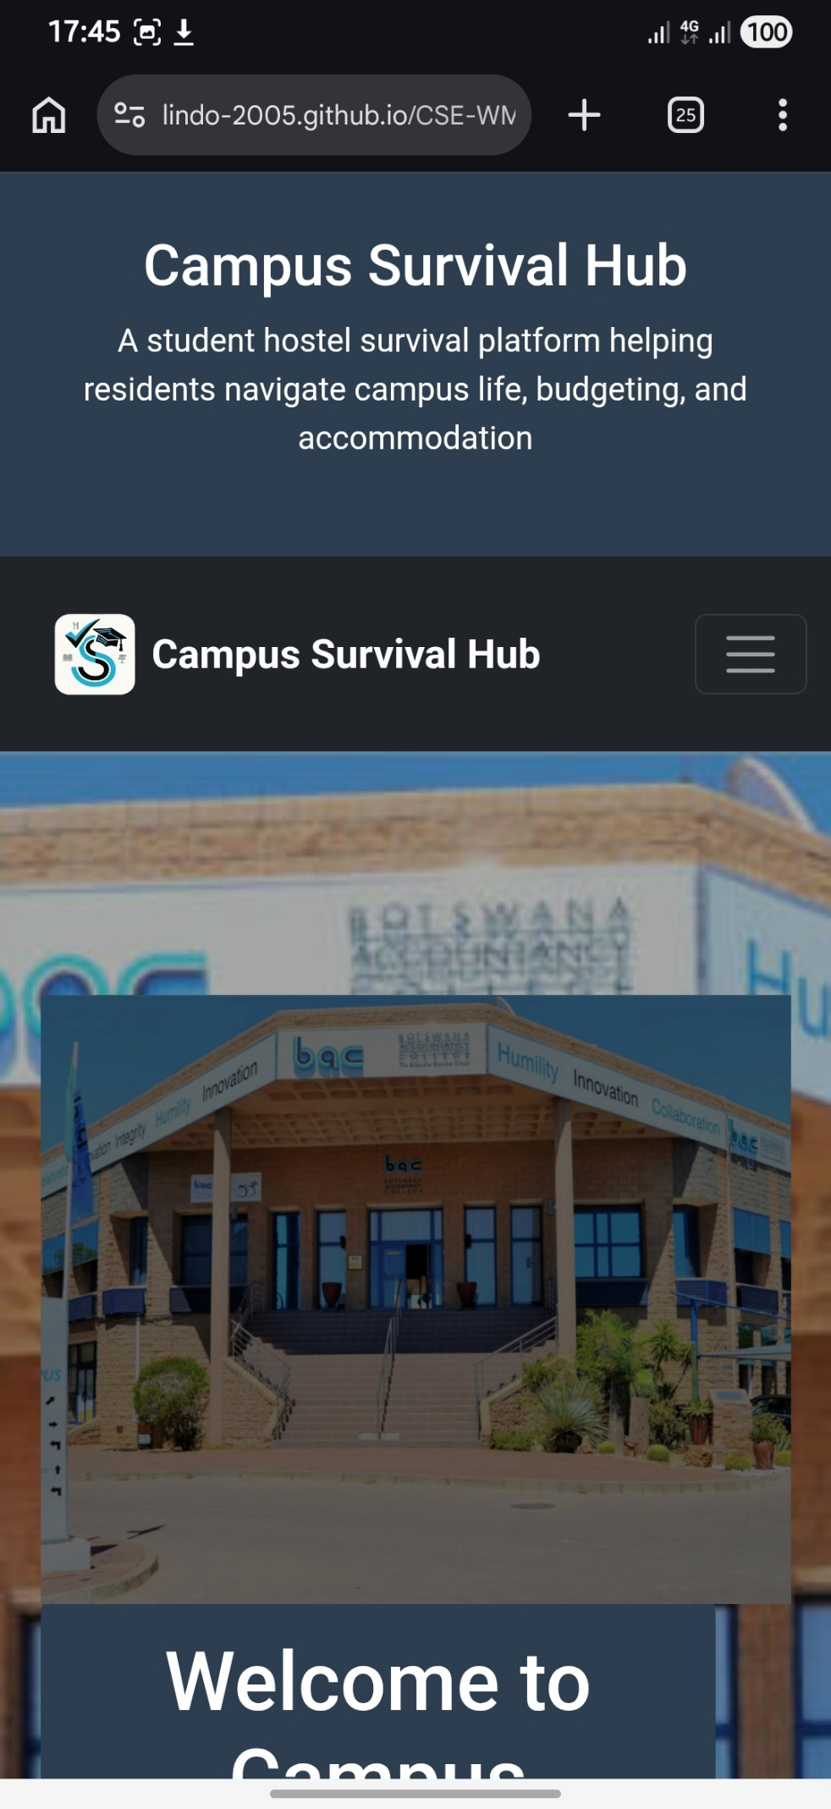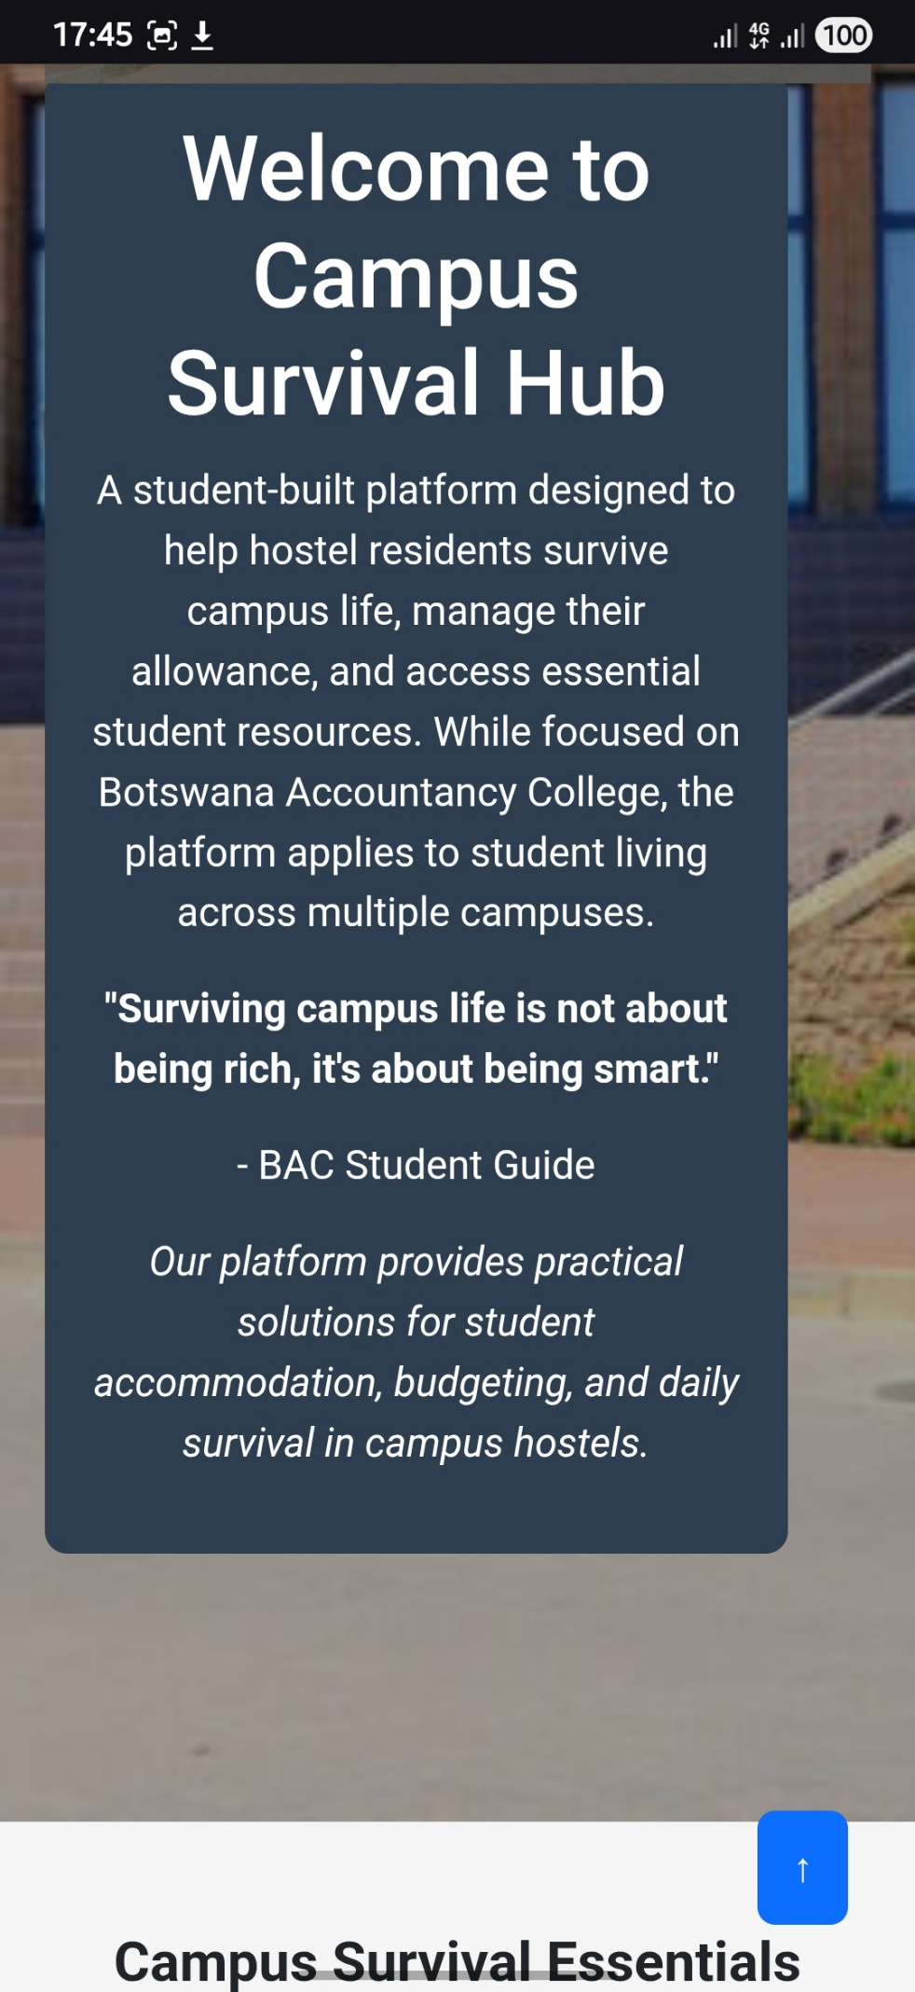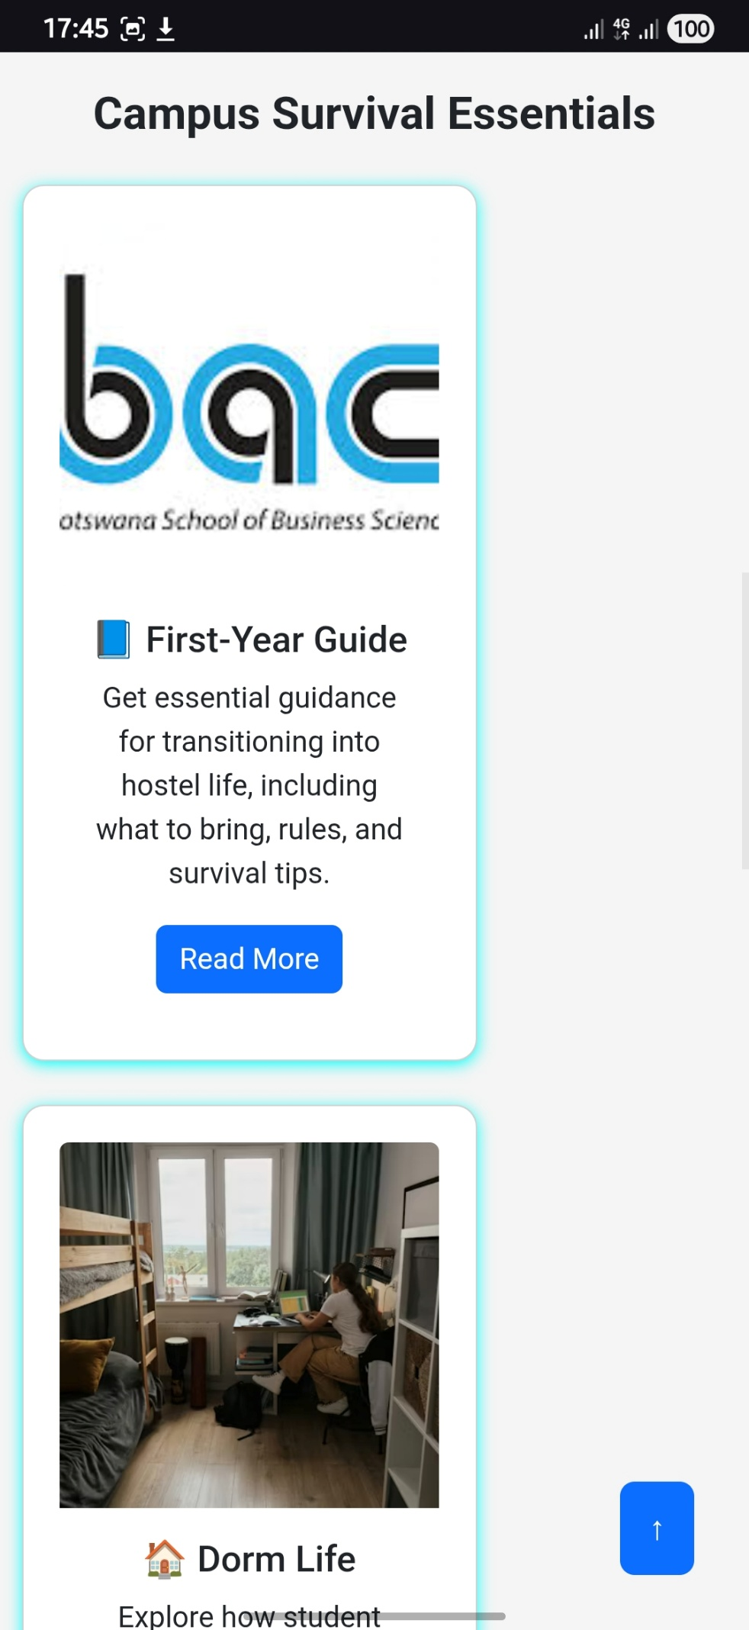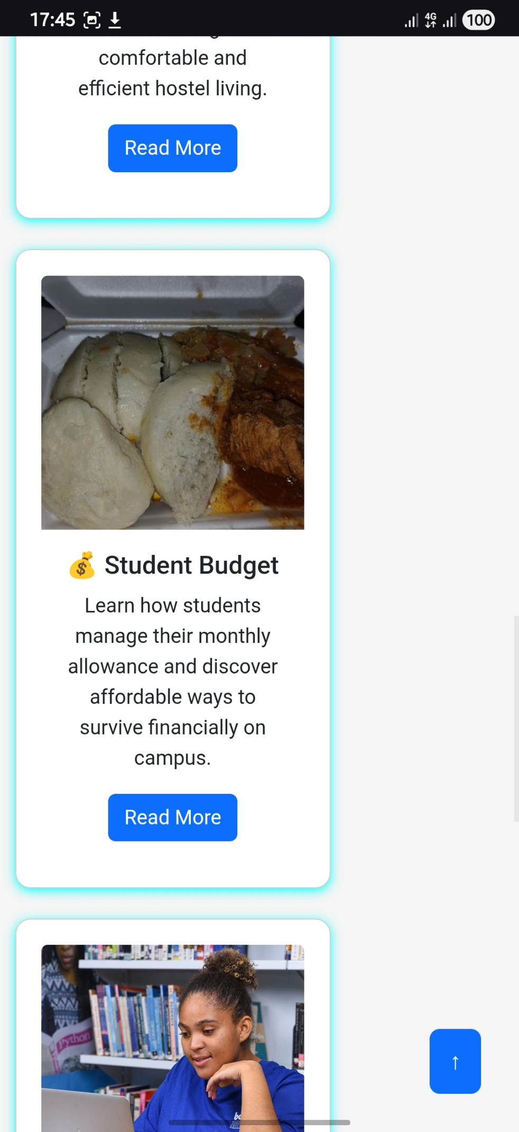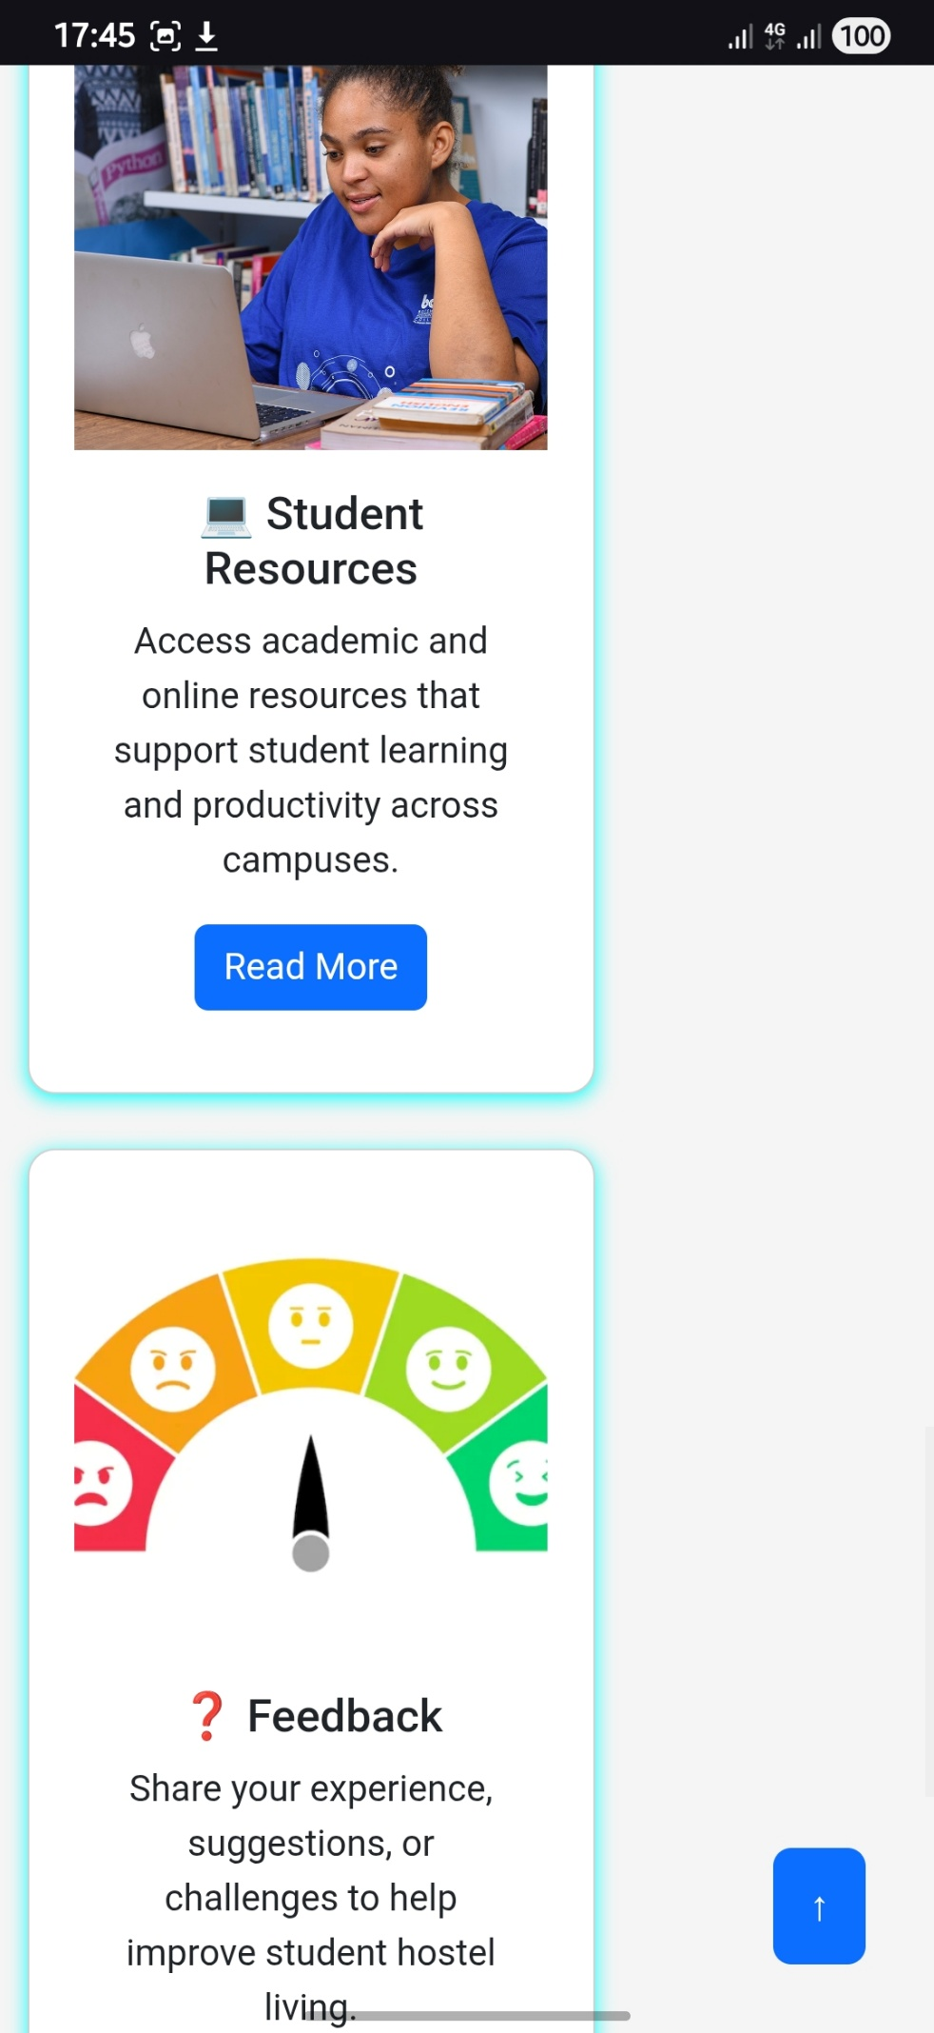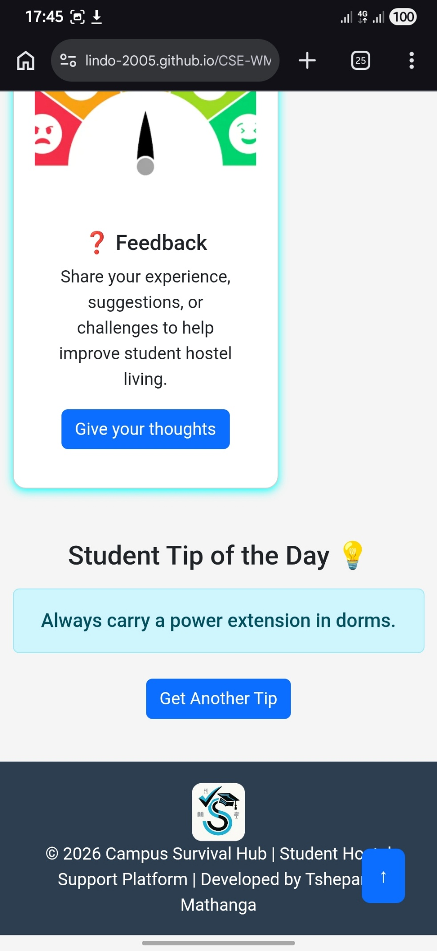

Publishing and Hosting
The website was published using GitHub Pages, which allows web projects to be hosted online and accessed through a web browser.
The project repository is available at:
https://github.com/Lindo-2005/CSE-WMD-Assignment
The live website can be accessed at:
https://lindo-2005.github.io/CSE-WMD-Assignment/
GitHub Pages was used to deploy the website, making it publicly accessible on the internet. This allows users to view the website on different devices such as smartphones, tablets, and desktop computers.
GitHub also provides version control, which helps track changes made during development and ensures proper project management.

FUTURE IMPROVEMENTS
There are several improvements that could be made in the future:
- Adding user login system for personalised experiences
- Expanding the platform to include multiple universities and hostels
- Improving the design with more advanced animations and features
- Adding real time communication features such as chats or forums
These improvements would enhance the functionality and usability of the website making it more interactive and beneficial for students

conclusion
In conclusion, the Campus Survival Hub website was successfully designed and developed to assist students living in hostels. The project demonstrated the use of HTML, CSS, Bootstrap, and JavaScript to create a responsive and interactive website.
The website provides useful information on dorm life, budgeting, and student resources, making it a valuable platform for students adjusting to campus life.
Through this project, valuable skills in web development, design, and problem-solving were developed. The use of GitHub for hosting also provided practical experience in deploying web applications.
Overall, the project achieved its objectives and meets the requirements of the assignment.

